**Create and Manage Containers on Minikube.**

1. **Create an yml file for POD creation**
2. **Create an yml file for Service creation**
3. **Run the yml files**
4. **Check whether the env is up and running, if not troubleshoot**
5. **Check the output of the Env.**
6. **Test the POD stability**
7. **Delete the POD and Services.**
8. **Create an yml file for POD creation**

apiVersion: v1

kind: Pod

metadata:

name: client-pod

labels:

component: web

spec:

containers:

- name: client

image: payalbnsl/tomcat

ports:

- containerPort: 8080

the file is saved as **“client-pod.yaml”**

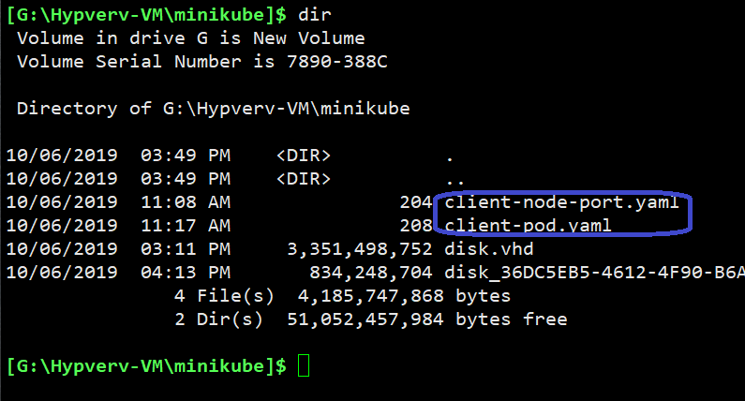

Note: -- The yaml files are stored on the local desktop

1. **Create an yml file for Service creation**

apiVersion: v1

kind: Service

metadata:

name: client-nodeport

spec:

type: NodePort

ports:

- port: 8000

targetPort: 8080

nodePort: 31313

selector:

component: web

the file is saved as **“client-node-port.yaml”**

1. **Run the yml files**

**c:/> kubectl apply -f client-pod.yaml**

**c:/> kubectl apply -f client-node-port.yaml**

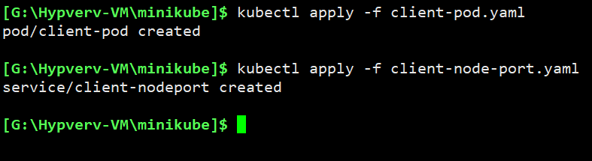

1. **Checking the status**

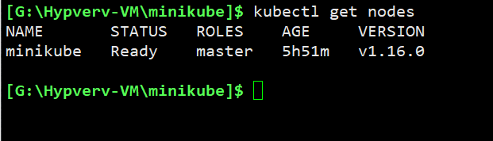

C:/> kubectl get nodes

This would list all the nodes (VM’s) in the kube cluster.

**C:/> kubectl get pod**

This would list all the pods running in the kube cluster

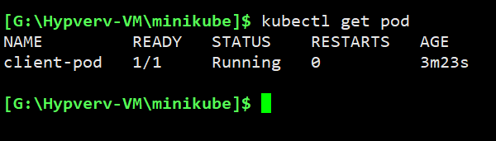

The 1/1 under ‘Ready’ says that there is ‘1’ POD up and running out of ‘1’ pod that needs to be running.

Age🡪 is showing for how long it is running.

**Troubleshooting.**

**Note**: -- if the Ready says ‘0/1’, which means the pod is not up.

Thinks that could have gone wrong are.

1. There is no sufficient resource available to create the POD’s.
2. The image required to run the POD is not getting downloaded, means in that case login to the minikube Vm and download the image manually like below.

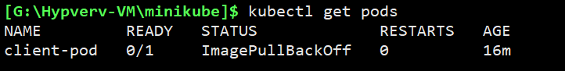



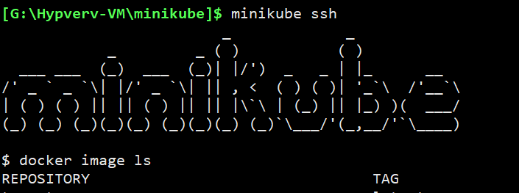

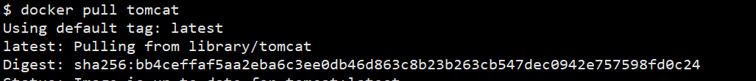

**$ docker pull tomcat**

This should most of the time resolve it.

**C:/> kubectl get service**

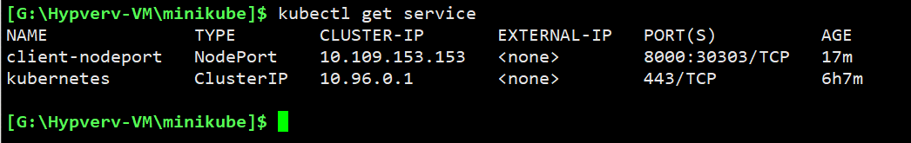

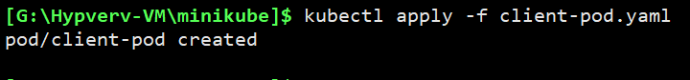

Lets create the POD again.

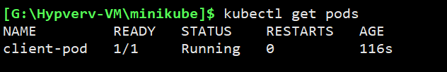

1. **Check the output of the Env.**

We would need the ip of the minikube vm, and use the “nodeport” port number defined in the services yaml file

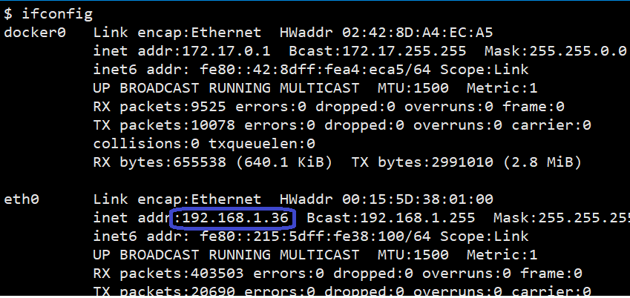

[**http://192.168.1.36:30303**](http://192.168.1.36:30303)

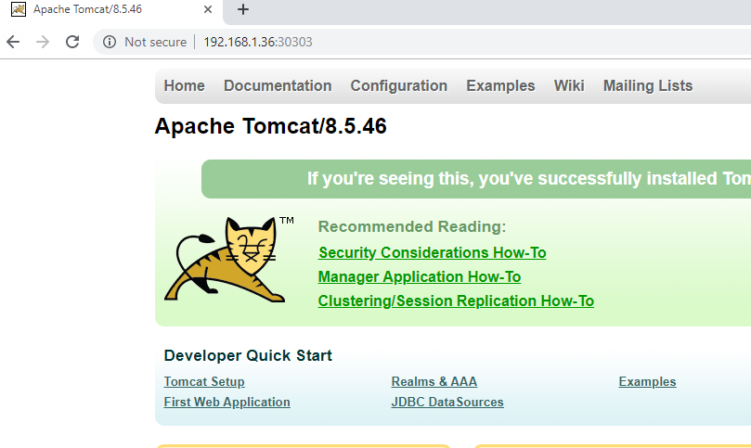

**Which means, we are successfully able to launch the tomcat inside the POD and access it from the external world.**

1. **Test the POD stability**

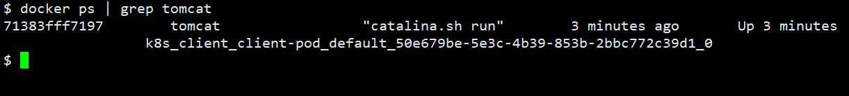

**The container is running.**

**Lets try to delete the container and lets see what happens**

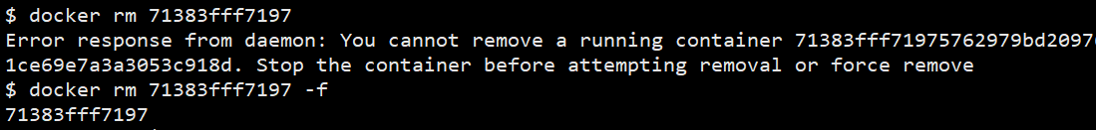





**The container is working fine.**

1. **Delete the Env.**

**C:/> kubectl delete -f client-pod.yaml**

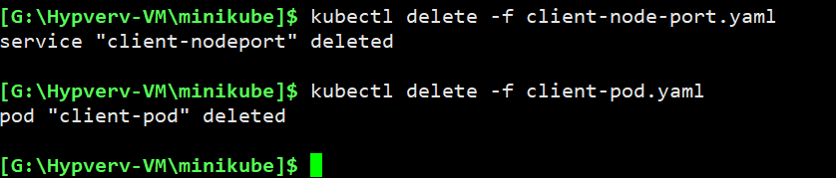

**C:/> kubectl delete -f client-node-port.yaml**

